**The Form output**

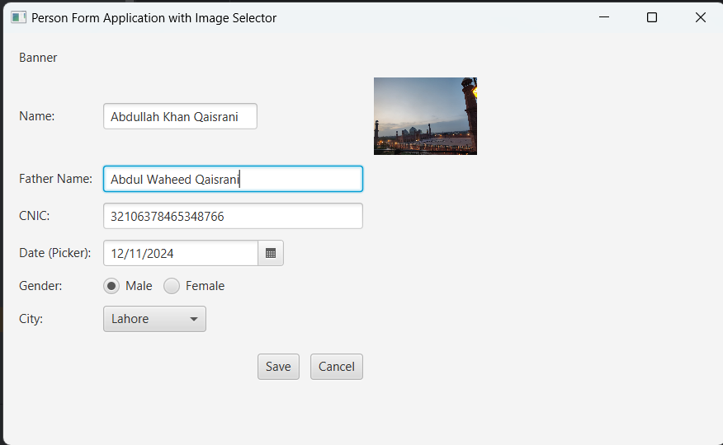

The **Banner Form** is a JavaFX interface for entering personal details like name, father’s name, CNIC, date of birth, gender, and city, with an image selector for a profile picture. It allows saving data to a list and displays the details in the console, along with options to clear inputs using the **Cancel** button.

**The Console output**

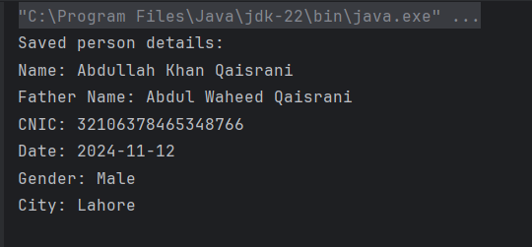

The **Console Output** displays the details of the person entered in the form after clicking the **Save** button. It shows the name, father's name, CNIC, date of birth, gender, city, and any selected image (if provided). The output is printed in a formatted manner, with each field displayed on a separate line for easy readability. If the required fields are not filled, a prompt is shown in the console to fill in the missing information.